Too Hot To Handle, Too Cold To Enjoy
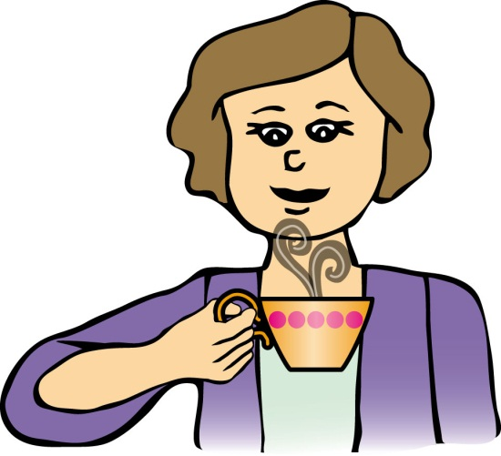
Have you ever taken a sip of coffee and burned your lip or tongue? Then after you set the coffee aside to cool, it gets too cold. This activity is designed for you to analyze why this happens and to help predict when to take that first sip.
In order to achieve this goal, you will take measurements of hot coffee (actually, simulated hot coffee) at various times, and then graph the results. Before you can determine the perfect time for the first sip, however, they must conduct some research to determine what temperature is hot enough to burn.

Liebeck v. McDonald's Restaurant, better known as the "McDonald's Coffee Case," was a lawsuit regarding a fast food restaurant and a person who was scalded by their coffee. The lawyer for the defendant said that McDonald's provided him its operations and training manual, which says its coffee must be brewed at 195–205° and held at 180–190° for optimal taste. Is this too hot to handle? How long should the defendant have waited to take that perfect first sip? Complete this lesson to find out; it could save your lips and tongue.
1. For a cooling cup of coffee, what kind of mathematical model would best represent the relationship between time and temperature? Is the function linear, absolute value, quadratic, square root, exponential or logarithmic?

2. Using the video provided for you at the computer, record the time and temperature at 8 different instances. Use the table to record data points.
TIME (t) | TEMPERATURE (T)
3. To graph the data above, which variable should be used for the domain? Why?

4. To graph the data above, what should the scale for the domain be? For the range?

5. What is the scale interval for the x-axis? For the y-axis?

6. Graph the points as a scatterplot.
7. Now that you can see the graph, what type of function models the relationship between temperature and time?

8. When tap water reaches 140º F, it can cause a third degree (full thickness) burn in just five seconds. Should McDonald's modify its training manual to take this information into account? Why or why not?

9. After your coffee is poured, how much time should you wait before you take the first sip?

10. If the coffee was left to cool for much longer than 30 minutes, what temperature would it reach? Why? Will the temperature continue to decrease until it reaches 0°?

11. What is the name for the concept that describes the limit that the temperature will never get to?

12. What is the inverse of exponential decay? If you were to heat a liquid and measure the temperature as the liquid gets hotter over time, would the graph look like the inverse of the exponential function?

13. What factors might affect the cooling rate of hot coffee?

