Math Shortcuts & Tips

Greatest Common Factor using Subtraction
1) Subtract the smaller number from the larger  2) Subtract the smallest two numbers from the previous equation.  3) Continue the process this process until your answer is zero.  4) When your answer is zero, look at your previous answer. That is your GCF | Example: 20 & 14  20 – 14 = 6  14 – 6 = 8  8 – 6 = 2  6 – 2 = 4  4 – 2 = 2  2 – 2 = 0  GCF is 2

Changing Improper Fractions to Mixed Numbers using Subtraction
1) Subtract denominator from the numerator  2) Continue subtracting the denominator from the solution until the number you obtain is smaller than the denominator. This number is the numerator of the fractional part of your mixed number.  3) Count the number of times you subtracted the denominator. This is the whole number of your mixed number.  4) The original denominator remains the same. | Example: $\frac{17}{5}$  17 – 5 = 12  12 – 5 = 7  7 – 5 = 2  3 $\frac{2}{5}$

Keep, Change, Change for Subtracting integers
- Keep the first number exactly the same.  - Change the subtraction sign to an addition sign.  - Change the sign of the last number to the opposite sign. If the number was positive change it to negative OR if it was negative, change it to positive. | Example: 6 – (-2)  6 – (-2) -7 – 5  6 + (2) = 8 -7 + (-5) = -12

Lattice Multiplication
Lattice multiplication is a method of multiplying large numbers using a grid. It is algorithmically equivalent to regular long multiplication, but the lattice method breaks the multiplication process into smaller steps, which some students find easier. Digits to be carried are written within the grid, making them harder to miss.

SETTING UP THE LATTICE
- First, draw a grid that has as many rows and columns as the multiplicand and the multiplier. The grid shown here is for multiplying a 4-digit number by a 3-digit number.
- Next, draw a diagonal through each box from upper right corner to lower left corner. Continue the line a short way past the grid.
- Write one factor across the top and the other down the right side, lining up the digits with the boxes.
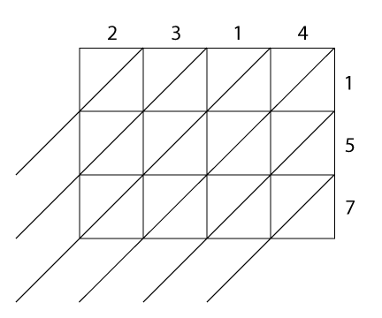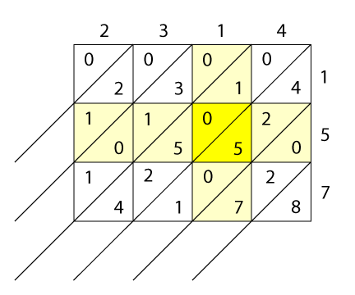

MULTIPLICATION
- The multiplication is performed by multiplying the digits at the head of each row and column. Fill in each square of the grid with the product of the digits above and to its right, recording the products so that the tens are in the upper (diagonal) half of the square and the ones are in the lower half. If the product does not have a tens digit, record a zero in that triangle.
- In the example shown above, the highlighted row and column give us 1×5=5, so we write 0 in the upper half of the square and 5 in the lower half.

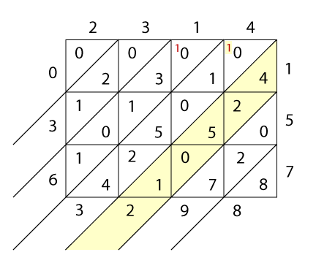
ADDITION
- Now add the numbers in the grid along the diagonals, starting from the lower right corner. Carry any tens into the top of the next diagonal.
- In this example, the highlighted diagonal gives us 4+2+5+1=12, so we write 2 at the bottom of the diagonal and carry the 1 to the top of the next diagonal to the left.

- To find the answer, read the digits starting down the left of the grid and continuing across the bottom. Here, the answer to 2314×157 is 363,298.

Lattice multiplication of decimals
Lattice multiplication can easily be extended to multiply decimal fractions. Suppose, instead of the above problem, we wanted to multiply 2.314 by 1.57. We would proceed as before, but draw lines from the decimal points down and to the left until they meet, then follow the diagonal to the left or bottom of the grid. The point where this diagonal emerges from the grid is the position of the decimal point in the answer.

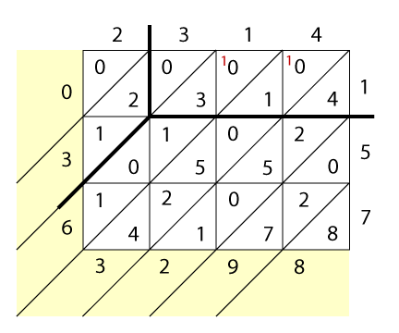Here, the result of the multiplication is 2.314 × 1.57 = 3.63298.

GCF and LCM using a Venn Diagram
- Find the prime factorization of each number.
- Put the shared factors in the intersection of the Venn diagram.
- Put the non-shared factors in the appropriate circle.
- The GCF is the product of the factors in the intersection.
- The LCM is the product of all the factors.

