8-1 Identifying Quadratic Functions
Objectives: Identify quadratic functions and determine whether they have a minimum or a maximum. Graph a quadratic function and give its domain and range.
A quadratic function is any function that can be written in the standard form y = ax² + bx + c, where a, b, and c are real numbers and a ≠ 0.
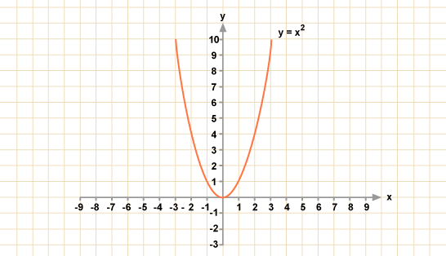
*Note: The differences between y-values for a constant change in x-values are called
first differences.

*Note: The differences between first differences of a function are second differences.

x | 0 | 1 | 2 | 3 | 4
y = x² | 0 | 1 | 4 | 9 | 16

*Note: Quadratics do not have constant first differences but do have constant second
differences.

Example 1: Tell whether each function is a quadratic. Explain.

- {(-2, -9), (-1, -2), (0, -1), (2, 7)}

- y = 7x + 3

- y – 10x² = 9

*Note: The graph of a quadratic function is a curve called a parabola.

Example 2: Use a table of values to graph each quadratic function.
- y = $\frac{1}{3}$x²

- y = -4x²

*Note: A parabola opens upward when a > 0.
A parabola opens downward when a < 0
Example 3: Tell whether the graph of each quadratic function opens upward or downward. Explain.
- y - $\frac{1}{4}$x² = x – 3

- y = 5x – 3x²

*Note: The highest or lowest point on a parabola is the vertex.

Minimum and Maximum Values
If a > 0, the parabola opens upward, and the y-value of the vertex is the minimum value of the function. | If a < 0, the parabola opens downward, and the y-value of the vertex is the maximum value of the function.
y = x² + 6x + 9 | y = -x² + 6x - 4

Example 4: Identify the vertex of each parabola. Then give the minimum or maximum value of the function.

*Note: Unless domain is specified, assume the domain of a quadratic function is all real
numbers.
Range is where all of the y-values of the function exist.

Example 5: Find the domain and range.

