8-9 The Quadratic Formula and the Discriminant
Objective: Solve quadratic equations by using the Quadratic Formula. Determine the number of solutions of a quadratic equation by using the discriminant.
The Quadratic Formula: The solutions of ax² + bx + c = 0, where a ≠ 0, are x = $\frac{-b± \sqrt{b^{2}-4ac}}{2a}$.
Example 1: Solve using the Quadratic Formula.
- 6x² + 5x – 4 = 0

- x² = x + 20

Example 2: Solve x² + 3x – 7 = 0 by using the Quadratic Formula.

The discriminant of the quadratic equation ax² + bx + c = 0 is b² – 4ac.

Equation | x² – 4x + 3 = 0 | x² + 2x + 1 = 0 | x² – 2x + 2 = 0
Discriminant | a = 1, b = –4, c = 3  b² – 4ac  (–4)² – 4(1)(3)  16 – 12  4  The discriminant is positive. | a = 1, b = 2, c = 1  b² – 4ac  (2)² – 4(1)(1)  4 – 4  0  The discriminant is zero. | a = 1, b = –2, c = 2  b² – 4ac  (–2)² – 4(1)(2)  4 – 8  –4  The discriminant is negative.
Graph of Related Function | Notice that the related function has two x-intercepts.  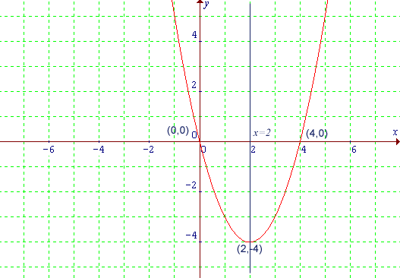 | Notice that the related function has one x-intercept. | Notice that the related function has no x-intercepts.
Number of Solutions | Two real solutions | One real solution | No real solution

The Discriminant of Quadratic Equation ax² + bx + c = 0
- If b² – 4ac > 0, the equation has two real solutions.
- If b² – 4ac = 0, the equation has one real solution.
- If b² – 4ac < 0, the equation has no real solutions.
Example 3: Find the number of real solutions of each equation using the discriminant.
- 3x² – 2x + 2 = 0

- 2x² + 11x + 12 = 0

- x² + 8x + 16 = 0

